**Lab 3: How to Use the Spectrometers**

**Setup:**

When balancing the telescope we had to use the plyers to adjust the counterweight. We used the tracking method to observe a random bright star in the East. After we centered the object in the scope, we left it to track for a half hour to see if it was still there which it was.

**Calibration:**

We first set up the spectrometer inside to start the calibration. We pointed the fiber optic cable at the light first but it had such a high intensity the spectra gave no useful data. We ended up using the reflection off of the projector screen. We used the florescent and neon light to get calibration spectra from those. However, we made an error and only took a single part of the spectra for the calibration.

**Observations:**

In this lab, we made some cool observations. First we looked at Vega which was kind of underwhelming in our spectra. Capella was slightly better. But for the Ring Nebula we made two key observations, Frank is a God for finding it by eye, and the emission lines looked fantastic (or so we thought). Then as the night went on we also observed and took spectra of the Dumbbell Nebula, Betelgeuse, and M42.

**Results:**

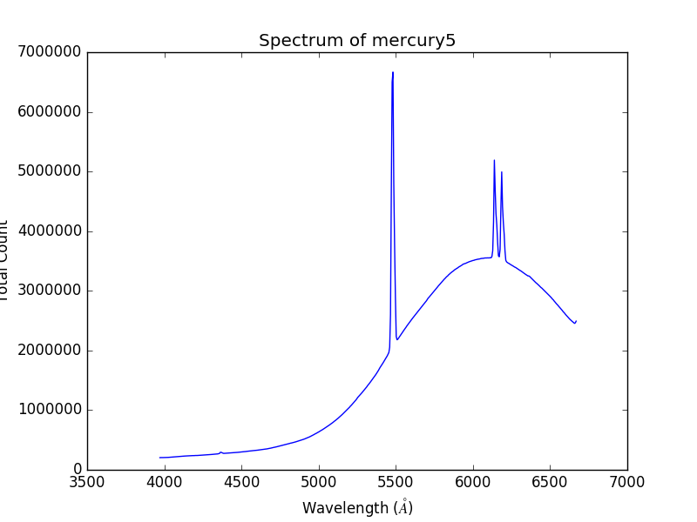 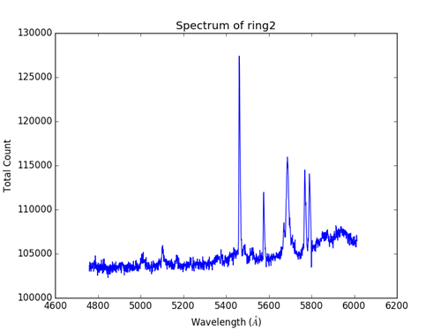

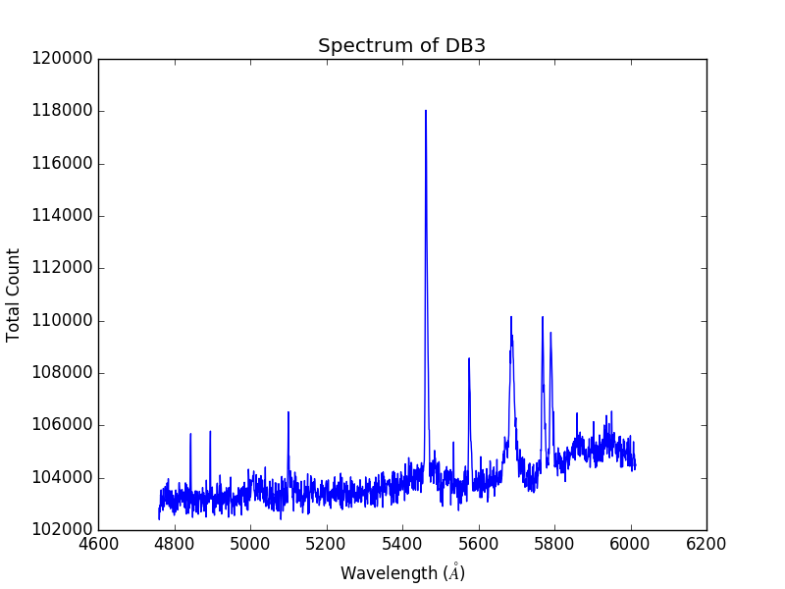

Top left is the calibration line for the fluorescents. Top right spectra of the Ring Nebula. Bottom left spectra of Dumbbell Nebula.

So in the Ring and Dumbbell spectra we forgot to turn off the fluorescents in the building so they dominate these two Nebula spectra.

**Vega**

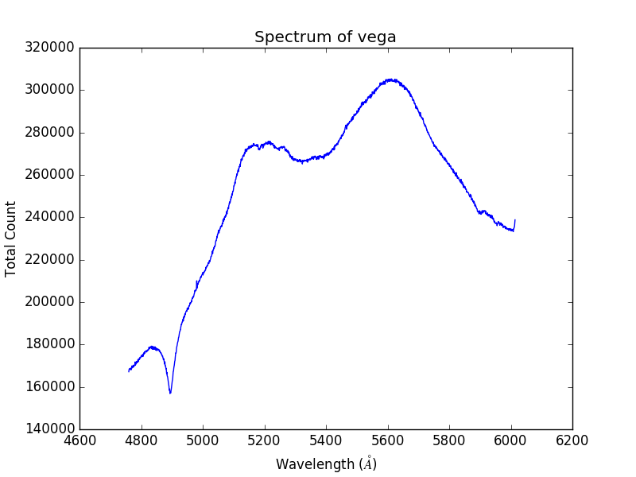

**H2O**

In our spectra of Vega, we believe that the pixels overflowed and spilled over into all the others in the 5600 Å region. You can sort of see this in the FITS file.

**Na I**

**Mg I**

**Fe II**

**Hβ**

**Capella**

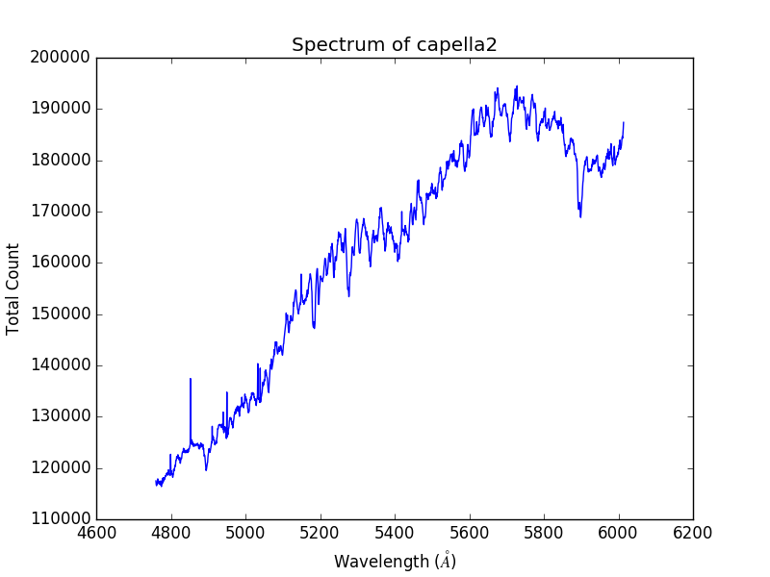

**Hβ ?**

**Na I**

**Mg 1B**

**Betelgeuse**

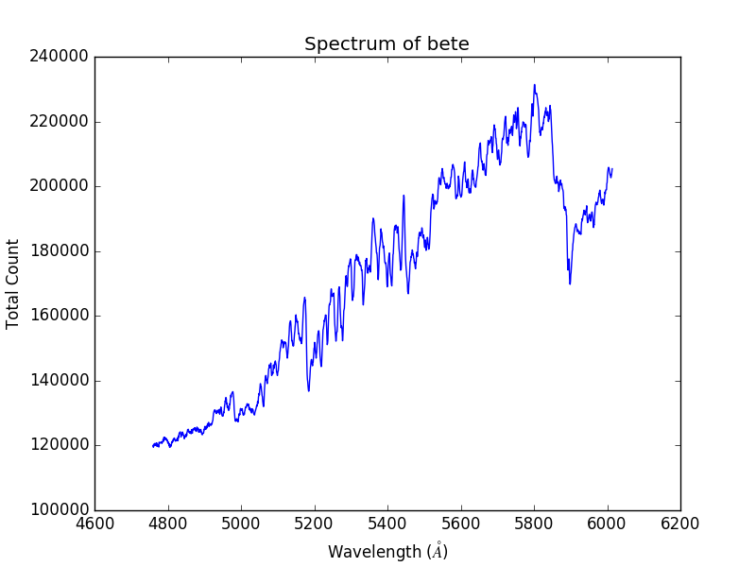

**Fe I**

**Mg I**

**VO**

**Hβ**

**TiO**

**He I**

**C III**

**Dumbbell**



We think that this spectra is mostly just background signals.

(We may have lost tracking not entirely sure though)

**Hβ**

**M42**

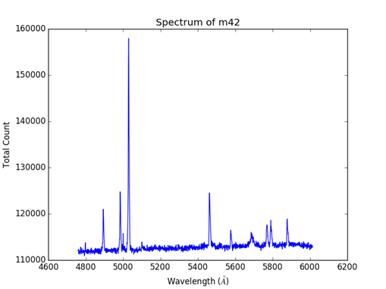

**OI**

**He I**

**OIII**

**Hβ**

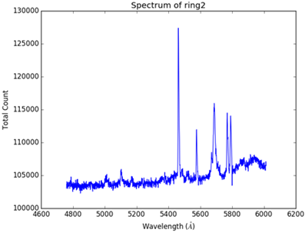**Ring Nebula**

For the Ring Nebula all the strong lines are not in this wavelength range.

**OIII**

(For all of these spectra, we used a python script because the VisualSpec program wouldn’t work for us. In the interest of time, we couldn’t get the calibration lines out from the spectra but took time going through to try and find the lines by hand.)